Sunday | Monday | Tuesday | Wednesday | Thursday | Friday | Saturday
 |  |  |  | 1 | 2 | 3
4 | 5 | 6 | 7 | 8 | 9 | 10
11 | 12 | 13 | 14 | 15 | 16 | 17
18 | 19 | 20 | 21 | 22 | 23 | 24
25 | 26 | 27 | 28 | 29 | 30 | 31

  First Floor  Fox Crossing & TCU Calendar |  |  |  | 9:30 SAIL Fitness Class CH  10:15 Mass CH  10:30 Door Decoration Craft AR  1:30 MacPhail GR  3:30 MN State Fair Jeopardy  7:00 Movie “Spider-man 2”  Ch 1-4 | 9:30 SAIL Fitness Class CH  10:30 Dice Games  2:00 Ninja Turtle Movie & Popcorn CH  7:00 Movie “The Amazing Spider-man” Ch 1-4 | 11:00 Daily News/ Exercise/ Trivia  3:30 Movie Ch 1-4  7:00 Movie Ch 1-4
9:30 Ecumenical Service of the Word CH  9:30 Catholic Communion Service GR  3:30 Movie Ch 1-4  7:00 Movie Ch 1-4 | 9:30 SAIL Fitness Class CH  10:30 Art in the Bible FC  12:30 Knit Whits CH  2:00 Bingo GR  3:30 Choir CH  7:00 Movie “Iron Man 2” Ch 1-4 | 9:30 SAIL Fitness Class CH  10:30 Chaplain Chat’s CH  1:30 MLCC County Fair  MLCC/MW’s Parking Lot  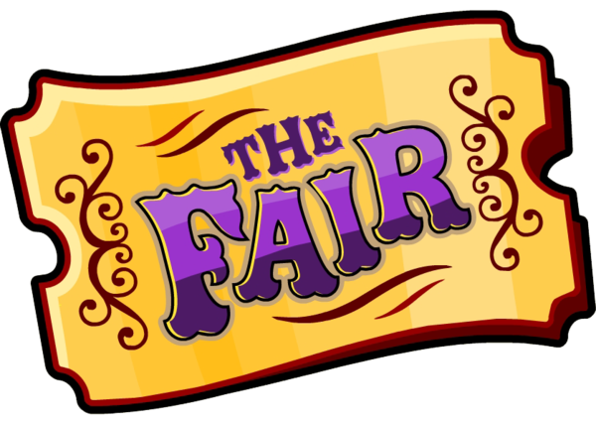  7:00 Movie “Iron Man 3” Ch. 1-4 | 12:10 Twins vs Braves  9:30 SAIL Fitness Class CH  10:30 Ecumenical Communion CH    7:00 Movie “Justice League”  Ch. 1-4 | 9:30 SAIL Fitness Class CH  10:15 Rosary CH  10:30 Mystery Trivia  3:30 Water Balloon Fun  7:00 Movie “Captain America: The Winter Soldier” Ch 1-4 | 9:30 SAIL Fitness Class CH  10:30 Card Games  2:00 Happy Hour w/Jim Roth “Old Time Rock and Classics” GR    7:00 Movie “Man of Steel” Ch 1-4 | 11:00 Daily News/ Exercise/ Trivia  3:30 Movie Ch 1-4  7:00 Movie Ch 1-4
9:30 Ecumenical Service of the Word CH  9:30 Catholic Communion Service GR  3:30 Movie Ch 1-4  7:00 Movie Ch 1-4 | Padelford Riverboat Cruise  9:30 SAIL Fitness Class CH  10:30 Art in the Bible FC  12:30 Knit Whits CH  2:00 Bingo GR  3:30 Choir CH  3:30 Superhero Popcorn Making for Fundraiser AR  7:00 Movie “Avengers: Age of Ultron” Ch 1-4 | 9:30 SAIL Fitness Class CH  10:30 Gardening w/ Melissa AR  10:15 Hymns & Harmonica CH  1-3:30 Resident Council Fundraiser  2:00 Root Beer Float Social    7:00 Movie “Black Panther” Ch. 1-4 | 9:30 SAIL Fitness Class CH  10:30 Apples to Apples  10:30 Ecumenical Memorial & Healing CH  2:00 Resident Photo Session  7:00 Movie “Ant-Man” Ch. 1-4 | 9:30 SAIL Fitness Class CH  10:15 Mass CH    10:30 Outdoor Squirt Gun Painting MG  1:30 MacPhail GR  3:30 Woodstock Throwback  7:00 Movie “Guardians of the Galaxy Vol. 2” 1-4 | 9:30 SAIL Fitness Class CH  10:30 Watercolor w/Artistry AR  2:00 Quarter Bingo  7:00 Movie “Suicide Squad”  Ch 1-4 | 11:00 Daily News/ Exercise/ Trivia  3:30 Movie Ch 1-4  7:00 Movie Ch 1-4
9:30 Ecumenical Service of the Word CH  9:30 Catholic Communion Service GR  3:30 Movie Ch 1-4  7:00 Movie Ch 1-4 | 9:30 SAIL Fitness Class CH  10:30 Art in the Bible FC  10:30 Resident Council CH  12:30 Knit Whits CH  2:00 Bingo GR  7:00 Movie “Doctor Strange” Ch 1-4 | 9:30 SAIL Fitness Class CH  10:30 Picture It  3:30 Lemonade Social  7:00 Movie “The Wolverine”  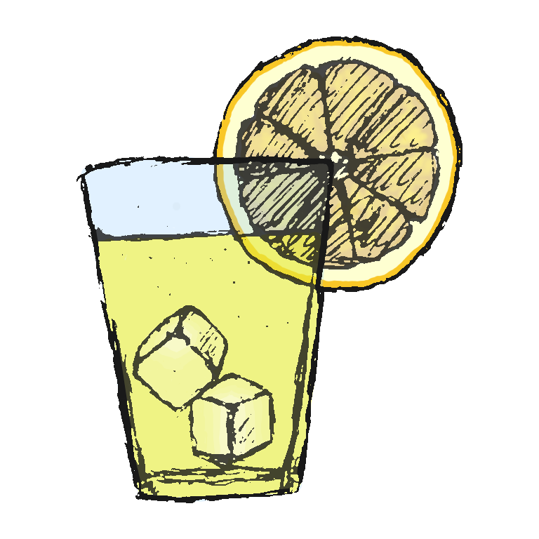  Ch 1-4 | 9:30 SAIL Fitness Class CH  10:30 Carnival Word Puzzles  10:30 Ecumenical Welcome & Communion CH  3:30 Cornhole  7:00 Movie “X-Men” Ch. 1-4 | 9:30 SAIL Fitness Class CH    10:15 Rosary CH  10:30 What’s in the Bag?  3:30 Finish the Lyrics  7:00 Movie “X-Men: First Class” Ch 1-4 | “Let’s Go Fishing” Trip  9:30 SAIL Fitness Class CH  10:30 Board Games  2:00 Dog Days of Summer GR  7:00 Movie “X-Men: Days of Future Past” Ch 1-4   | 11:00 Daily News/ Exercise/ Trivia  3:30 Movie Ch 1-4  7:00 Movie Ch 1-4
9:30 Ecumenical Service of the Word CH  9:30 Catholic Communion Service GR  3:30 Movie Ch 1-4  7:00 Movie Ch 1-4 | 9:30 SAIL Fitness Class CH  10:30 Art in the Bible FC    12:30 Knit Whits CH  2:00 Bingo GR  3:30 Choir CH  4:00 Superhero Design AR  7:00 Movie “The Last Airbender” Ch 1-4 | 9:30 SAIL Fitness Class CH  10:30 Gardening w/ Melissa AR  3:30 Going! Going! Gone! Discussion  7:00 Movie “Hulk” Ch. 1-4 | 9:30 SAIL Fitness Class CH  10:30 Ecumenical Service w/Choir CH    12:00 Birthday Luncheon  3:30 Cranium Crunches  7:00 Tailwaggers  7:00 Movie “The Story of Robinhood” Ch. 1-4 | 9:30 SAIL Fitness Class CH  10:15 Hymn Sing CH  10:30 Noodle Ball  3:30 Superhero Jeopardy  7:00 Movie “Fantastic 4” Ch 1-4 | 9:30 SAIL Fitness Class CH  10:30 Card Games  2:00 Quarter Bingo  7:00 Movie “Journey to the Center of the Earth” Ch 1-4 | 11:00 Daily News/ Exercise/ Trivia  3:30 Movie Ch 1-4  7:00 Movie Ch 1-4
GR-Great Room CH-Chapel MG- Memorial Garden FC-Fox Crossing EC-Eagle Crest AR-Art Room

