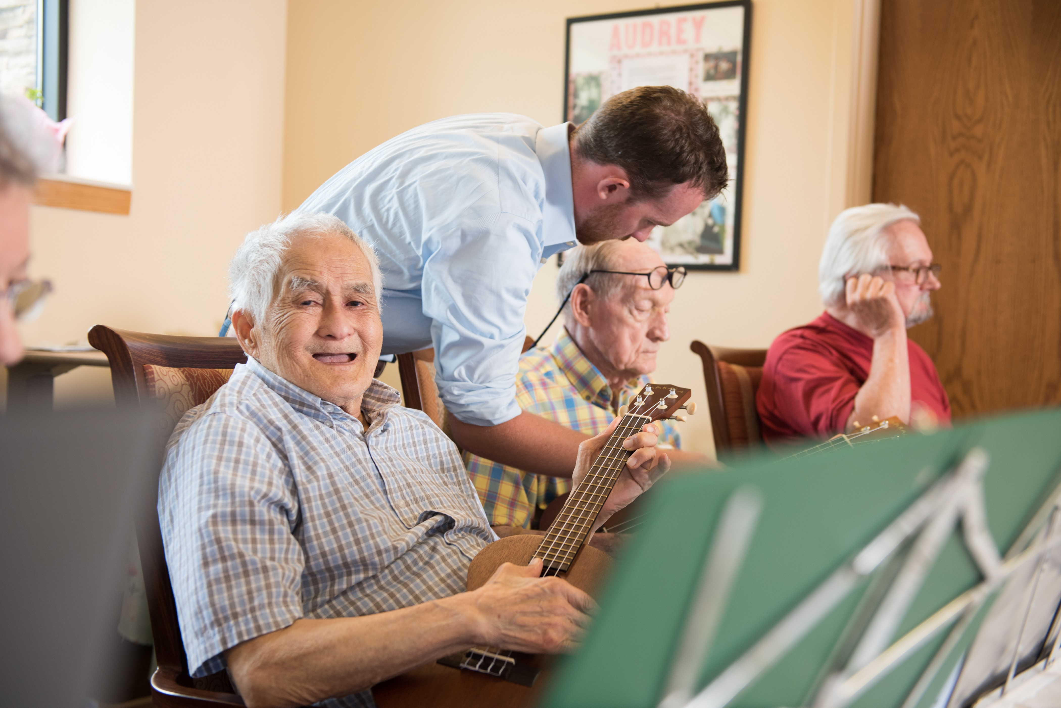

Martin Luther Campus

1401 E. 100th St.

Bloomington, MN 55425

Heather Liesenfeld

Director of Adult Day Services

952-948-5154

*as of 3-1-19*

**Adult Day Program Rates**

* **Full day program** (seven hours)**: $96.60**
* **Half day program** (four hours or less)**: $55.20**

*($13.48/hr after four hours)*

* **Transportation** (Round Trip)**: $20.00**
* **Transportation** (One-Way)**: $10.00**

*Early arrival or late departure of participants beyond hours of operation will be charged $10.00 per 15 minute increment.

*Cancellations not received 24 hours in advance of a scheduled day will be billed $15.00.

*“No shows” will be billed at the full day rate. *Exceptions will be made when absences are related to hospitalizations.*

*Participants are invoiced monthly. The period covered is noted on the customer statement. There is a late payment fee of $5.00.*

*Payment is due on or before the 15th of the month. The participant will not be able to attend the program until the fee for service has been received.*

*www.martinluthercampus.com  
© 2019 Fairview Health Services*